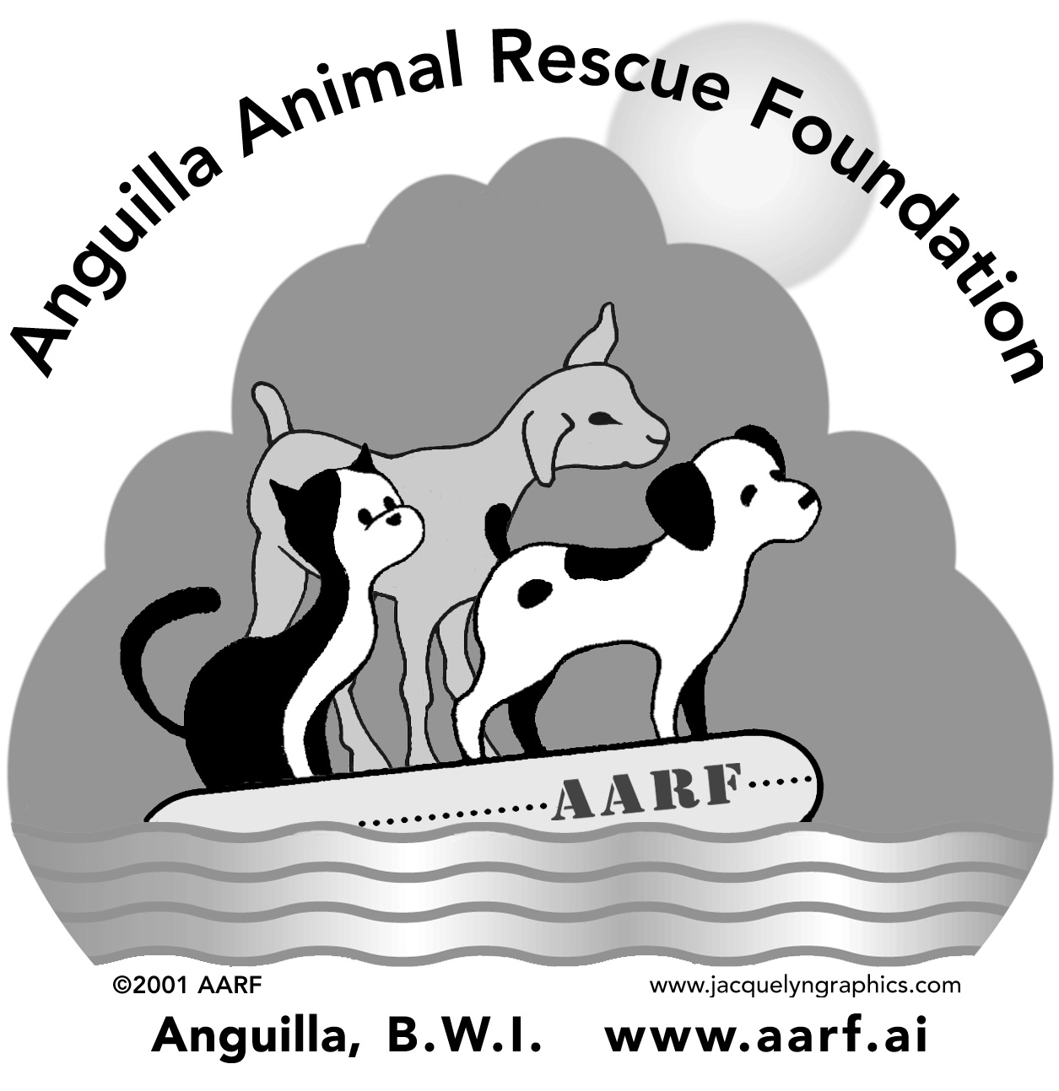 FREE SPAY/NEUTER PROGRAM APPLICATION FORM

Owner Information

Last Name: ________________________ First Name: ________________________

PO Box: ____________ Address: ________________________________________

Phone Number (Day): _____________ (Evening): ____________ (Cell): _______________

Email Address: ________________________________________

Animal Information:

Name: __________________________ Application Number: 0307 _________ (assigned by AARF)

Type:  - Dog  - Cat | Sex:  - Male  - Female | If female has she had a litter?  - Yes  - No  How Many? ________

Age: ___________ (specify years or months) Approximate Weight: ____________

Last Vaccination Date: _____________ Veterinarian Name: _____________________

Source of Animal:  - Bought, Price $ _______  - Found  - Adopted  - Community | From:  - Pet Shop  - Shelter  - Relative  - Breeder  - Friend  - Stray  - Other _______ | Things we should know about your Pet: (check all that apply):  - In heat  - Pregnant  - Fleas  - Ticks  - Friendly  - Bites/Scratches  - Feral  - Wounds ____________________  - Other health problems ____________  ________________________________

Do you have any interest in having your animal tested for heartworm or tick fever? ___ Yes ___ No

Do you have interest in having your animal vaccinated for various diseases? ___ Yes ___ No

Other Animals at Home: Please provide us with information on other animals you may have or care for.

____ # female dogs _____# spayed ____ # female cats _____# spayed

____# male dogs _____# neutered ____# male cats _____# neutered

If any of these animals are not spayed or neutered, will you apply for their inclusion in the program?
- Yes
- No

If yes, please note which animal(s) you will apply for: ____________________________________________

Please return forms by June 13, 2003 to: Morlen’s Veterinary Hospital or AARF, PO Box 537, The Valley, Anguilla

