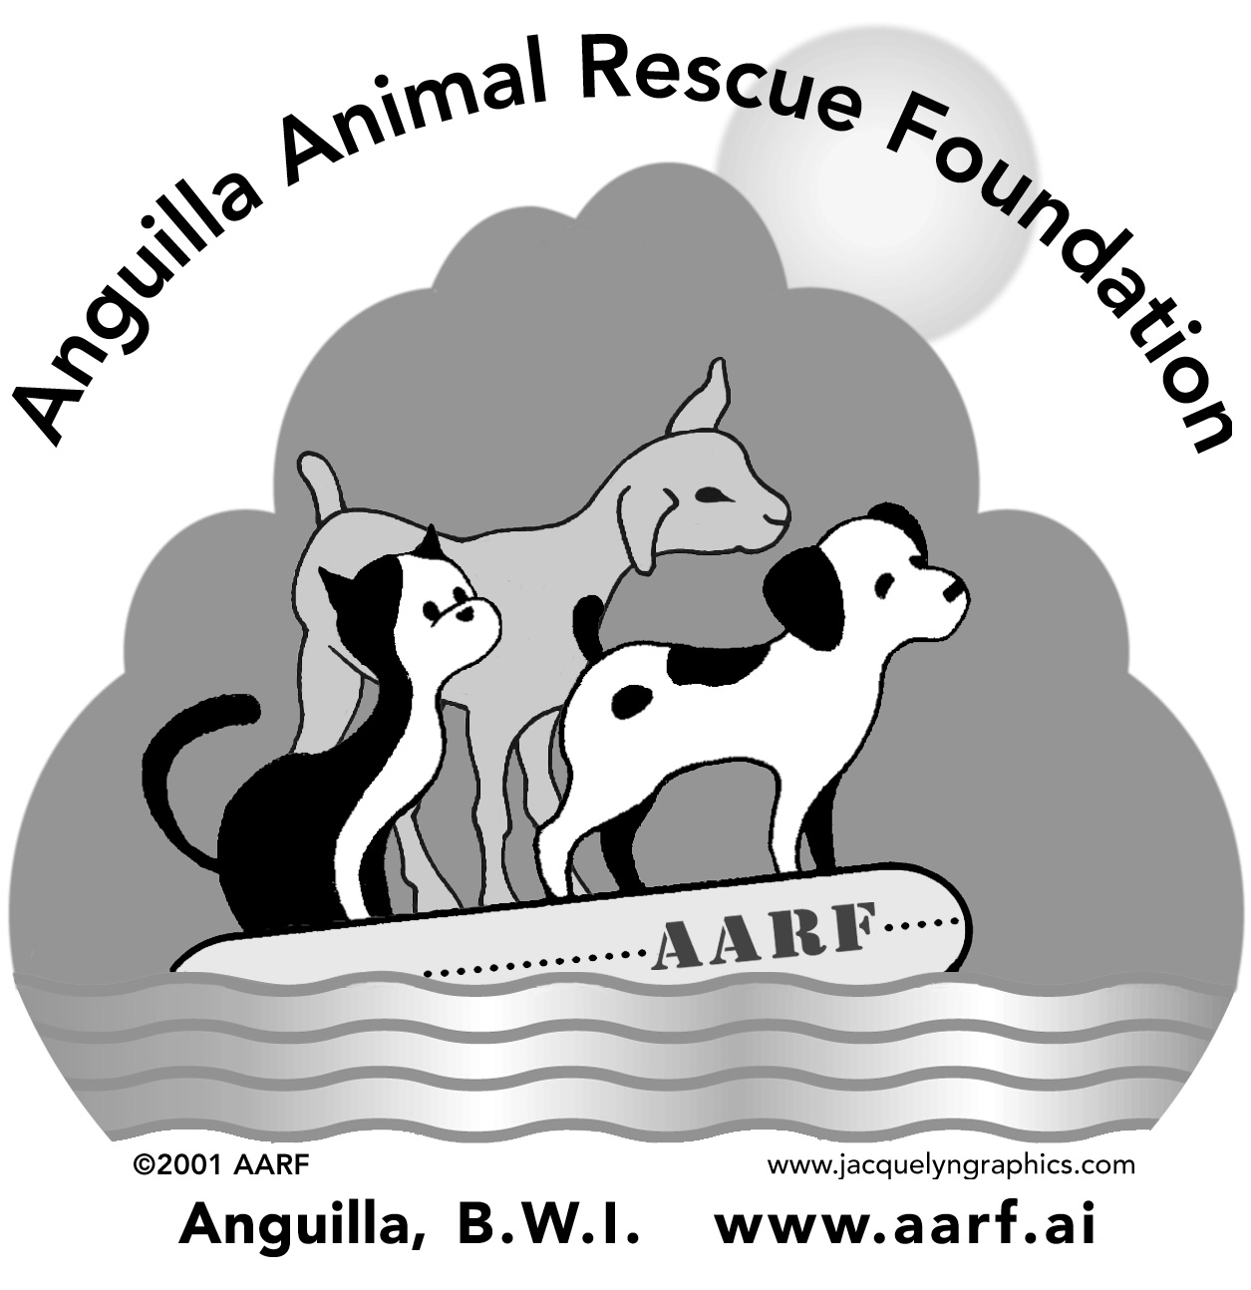 FREE SPAY/NEUTER PROGRAM APPLICATION FORM

Owner Information

Last Name: ____________________________ First Name: _______________________________

PO Box: ____________ Address: ________________________________________

Phone Number (Day): _____________ (Evening): ____________ (Cell): _______________

Email Address: ________________________________________

Animal Information:

Application Number: 04 _________ (assigned by AARF) Date Received by AARF: ___________________

Type: (dog/cat) | Sex (M/F) | Age | Color | Breed | Last Vaccine Date | Pet Name

Do you have any interest in having your animal(s) tested for heartworm or tick fever? ___ Yes ___ No

Do you have interest in having your animal(s) vaccinated for various diseases? ___ Yes ___ No

I understand that this is an application for surgery to have my animal spayed or neutered to stop its reproductive capabilities.

______________________________________ ____________________
Signed Date

Please return forms as soon as possible: Morlen’s Veterinary Hospital or AARF, PO Box RI 4228, Anguilla

