**HURRICANE PREPAREDNESS**

We have tips, guides and checklists to help animals get through a hurricane. The essential information follows:

**BEFORE THE STORM**

While there is still time, it is important to consider what we would do to protect our pets and the other animals in our care. We urge everyone to take the time to create a plan and assemble a Disaster Emergency Kit for your family that includes your pets. By taking these precautions now, you will be one step ahead if a hurricane threatens Anguilla.

AARF advises all pet owners to include the following in their Disaster Emergency Kit for their pet:

* Supply of dry food for 7 days in an airtight, waterproof container
* Drinking water for 7 days
* Bowls for food and water
* For dogs, include: leash, collar and a sturdy carrier
* For cats, include: litter, litter box, garbage bags to collect all pets’ waste, a litter scoop and a sturdy carrier
* Medications and medical records including vaccination records for each pet stored in a waterproof container
* First aid kit
* Current photos and descriptions of your pets to help others identify them in case you and your pets become separated and to prove that they are yours
* Carriers should be large enough for the animal to stand comfortably, turn around and lie down. Your pet may have to stay in the carrier for hours at a time. Be sure to have a secure cage with no loose objects inside it to accommodate smaller pets. These may require blankets or towels for bedding and other special items
* Pet beds and toys, to reduce stress
* Other useful items include: newspapers, paper towels, plastic trash bags, grooming items and household bleach

The single most important thing you can do to protect your pets if possible, is to **keep them with you**. Animals left to fend for themselves can easily be injured, lost or killed. Animals left alone inside your home can escape through storm–damaged areas, such as broken windows. Animals turned loose to be on their own are likely to become victims of exposure, starvation, predators, contaminated food or water or accidents. Leaving dogs or other animals tied or chained outside in a disaster is a death sentence.

If you must evacuate to a Hurricane Shelter where animals are not allowed, your pets should be left inside the house for their protection and others should be advised of their location. Make sure they have lots of water and some food (a boarded up home will get very warm inside).

If your family and pets can wait out a hurricane at home, identify a safe area of your home where you can all stay together. Be sure to close your windows and doors, stay inside, and follow the instructions from the local emergency management office.

Bring your pets indoors as soon as local authorities say there is an imminent problem. Pets have a way of knowing when storms are coming even though you may not be able to hear or see it. They may roam from home just when you do not want to spend time searching for them. Keep pets under your direct control; if you have to evacuate, you will not have to spend time trying to find them. Keep dogs on leashes and cats in carriers, and make sure they are wearing identification.

If you have a room you can designate as a "safe room," put your emergency supplies in that room in advance, including your pet’s crate and supplies. Have any medications and a supply of pet food and water inside watertight containers, along with your other emergency supplies.

Listen to the radio, and don’t come out until you know it’s safe.

AARF also recommends the following for owners of livestock animals including goats, cows, horses, chickens and pigs:

* Livestock should not be tied during storms as it prevents them from seeking shelter from high water and blowing debris.
* Ensure that poultry have access to high areas in which to perch especially if they are in a flood–prone area, as well as food and clean water.
* Obtain enough large containers to water your animals for at least a week as water supplies are often contaminated during a disaster.
* Secure or remove anything that could become blowing debris, if you have boats, feed troughs, or other large containers, fill them with water before the hurricane. This prevents them from blowing around and also gives you an additional supply of water.

**AFTER THE STORM**

Planning and preparation will help you survive the disaster, but your home may be a very different place afterward, whether you have taken shelter at home or elsewhere.

Don’t allow your pets to roam loose. Familiar landmarks and smells might be gone, and your pet will probably be disoriented. Pets can easily get lost in such situations.

While you assess the damage, keep dogs on leashes and keep cats in carriers inside the house. If your house is damaged, they could escape and become lost.

Be patient with your pets after a disaster. Try to get them back into their normal routines as soon as possible, and be ready for behavioral problems that may result from the stress of the situation. If behavioral problems persist, or if your pet seems to be having any health problems, talk to your veterinarian.

Hopefully, we will not be faced with any storms and hurricanes this season, but it is best to be prepared to face these stressful situations if they should occur – doing so could save the life of your pet and your livestock.

**ANGUILLA VETERINARY HOSPITAL, AARF AND GOVERNMENT CONTACTS**

Morlens Vet Clinic, AARF and AARF Shelter

Morlens Veterinary Clinic is Anguilla’s vet clinic, and specializes (only) in dogs and cats. Contact Morlens for cat/dog emergencies and for routine office matters concerning your pet. Its location is on the Eastern side of the island, in Sandy Hill, near the Sandy Hill roundabout. Call 264-581-4600 for emergencies as well as for routine matters.

The AARF shelter is in the same building as Morlens and is located in Sandy Hill, near the Sandy Hill roundabout. There are various ways to contact AARF, but the shelter phone number is 264-476-2731 and you the most general email address is aarfinfo@aarf.ai.

The AARF shelter is in the same building, which is located in Sandy Hill, near the Sandy Hill roundabout. Here are maps:

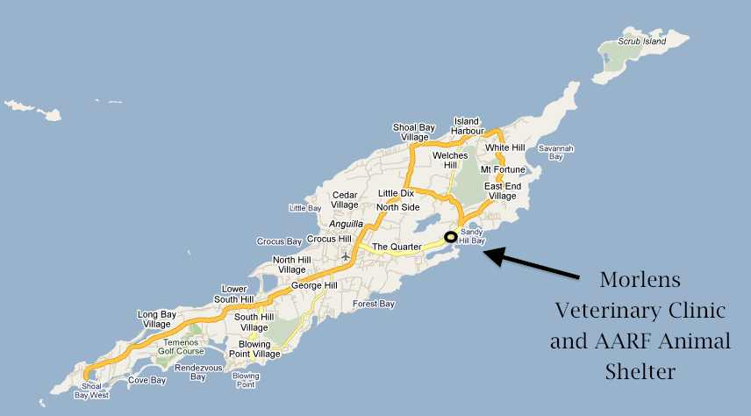

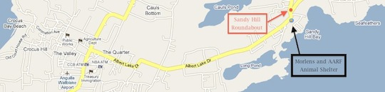

Anguilla Police

The Royal Anguilla Police Force (RAPF) should be contacted for police emergencies (call 911) and for all animal cruelty issues (at 264-497-2333).

Department of Agriculture

The Department of Agriculture handles animals other than dogs and cats. Call 264-497-2615.

**SINT MAARTEN / ST. MARTIN VETERINARY HOSPITALS**

DUTCH SIDE (SINT MAARTEN)

There are a couple of clinics on the Dutch side. If this information gets outdated, you can try www.sxmyellowpages.com and search for veterinarians.

St. Maarten Veterinary Clinic (near Kooyman)

The St. Maarten Veterinary Clinic (Dr. Garry Swanston attending) is in Cay Hill next to the monstrous Kooyman hardware store, which we think can be seen from the ISS. When coming down the hill from Marigot or the Cole Bay area, the clinic would be on the right just before the road above the Kooyman building. The address is:

* #25 Executive Commercial Building
* AC Brouwers Road
* Cay Hill
* St. Maarten

Phone numbers are:

* Office: 1-721-542-0111
* FAX: 1-721-542-2270
* Emergency: 1-721-587-1838 or
* Emergency: 1-721-587-2838

The web site has a nice searchable library, including the ability to search for diseases and medications. There is also a Facebook page.

There has been a change to US style numbers from the older 599-542-0111 style; now you dial 1-721 and the 7 digit phone number. It should make it easier to dial from Anguilla, or North America. Let us know if this works – or doesn’t.

Here is our own crude version of a map to the clinic; again, it is near Kooyman (which is shown by the letter “K” on the map):

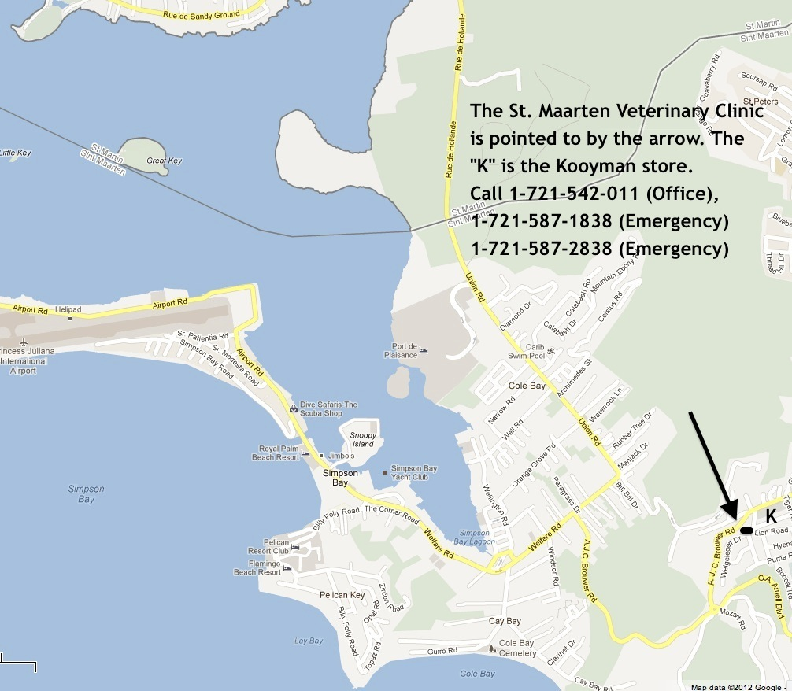

Animal Hospital of St. Maarten Veterinary Clinic (in Cole Bay)

Dr. Christopher & Teresa DeWitt run the Animal Hospital of St. Maarten in Cole Bay.

Phone numbers are:

* Office: 1-721 599-544-4111 or 1-721 599-544-4112
* Emergency: 1-721 599-587-3705

Hours of operation are:

* Monday, Wednesday and Friday 8am – 6pm
* Tuesday and Thursday 9am – 7pm
* Saturday 9am – 1pm

Again, we have our own crude map to the clinic:

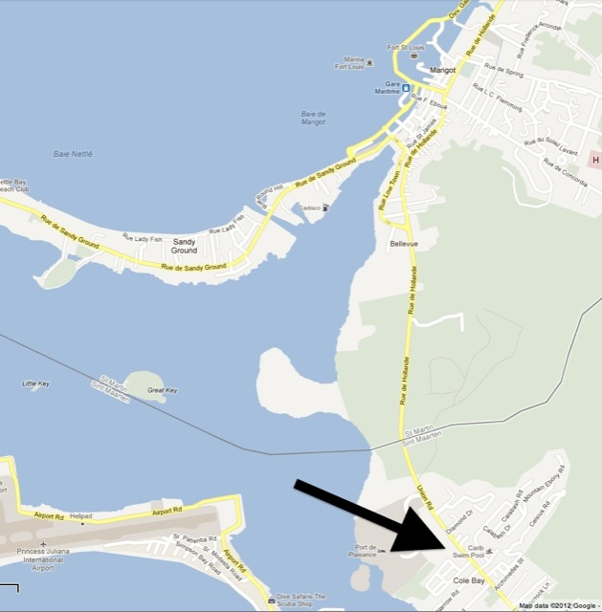

FRENCH SIDE (SAINT MARTIN)

Clinique Veterinaire De Hope Estate (Poulin-Menard) in St. Martin

This is a very modern, state of the art animal hospital with Dr. Poulin attending. Special medications and even foods are available.

To get to the hospital, head to the Grand Case airport from Marigot (head towards Orient Bay). Just past the far end of the airport (and just past the road leading to the airport), turn to the right. You will very shortly hit a T in the road. To the right you will see a supermarket. Go left instead and very shortly thereafter, take the first right. As the road curves around to the right (after a short distance), the clinic will be on the right.

The phone number is 1 590 590 87 15 05 from Anguilla. Using 011 instead of the leading 1 may work.

Hours are 9 a.m. to 7p.m. weekdays, 9 a.m. to 1 p.m. Saturdays (as of early 2012), but call and check first, or use their web site contact mechanism.

Here is the clinic’s web site, which is in French, but you can use Google translate to translate from French to English.

Our map is here:

