Anguilla Animal Rescue Foundation (AARF)
holds 5th Annual General Meeting

The Fifth AGM of the Anguilla Animal Rescue Foundation was held on Wednesday August 30th at Roy’s Bayside.

President, Chris Carty, welcomed everyone to the meeting at which
Suzie Donahue, AARF’s secretary, read the minutes of the previous AGM held on July 29, 2005 and Jimmy Carter gave the Treasurer’s report.

In her President’s Report, Chris Carty, noted that AARF is fast becoming a household word in Anguilla and stated that we had also gained recognition regionally and globally by our attendance this past spring at animal welfare conferences in Antigua and London.

President Carty reported that AARF continued this past year to focus on the spay/neuter program that is aimed toward those who have adopted from AARF, as well as some need-based cases. She recognized Dr. Patrick Vanterpool and Amy Williams for their continued support for AARF not only through the spay/neuter surgeries, but also for providing boarding and care for the unwanted animals here in Anguilla. Since the last AGM, AARF had found homes for 155 animals – most to Anguillian homes - by adoptions from Morlens Veterinary Hospital or AARF adoption days.

AARF’s other focus is Education and Chris thanked all those involved in the AARF Fun Page and recognized Mr. Nat Hodge of The Anguillian for his continuing contribution in printing this animal information page that is enjoyed by both children and adults.

Chris also thanked the members, volunteers and public for their attendance and support of our bingo and yard sale fundraising projects chaired by Althea Turner. Mrs. Carty reported that without any outside funding or grants, AARF has raised almost $15,000 US in 2006, and noted that over $10,000 had been spent caring for animals since last year.

President Carty also made the presentation of the Volunteer of the Year Award to Lynn Bartlett for her work on the Education committee in which she visited 7 schools and interacted with the children to teach them about positive animal care. Lynn also continues to support AARF at her business, Bartlett’s Collections, where she sell AAARF T-shirts and other AARF items and tells the many visitors to the island about AARF.

The Executive Board elected for the 2006 –07 year is:
President – Chris Carty
Vice President – Suzie Donahue
Secretary – Diane Sheehan
Treasurer – Jackie Pascher
Members at Large – Althea Turner & Gayle Gurvey

In closing President Carty asked the group to “ take a minute to step back and recognize the work being done, the progress being made, the challenges being met, and rejoice that so many of us are willing to stand up and give animals a voice.”

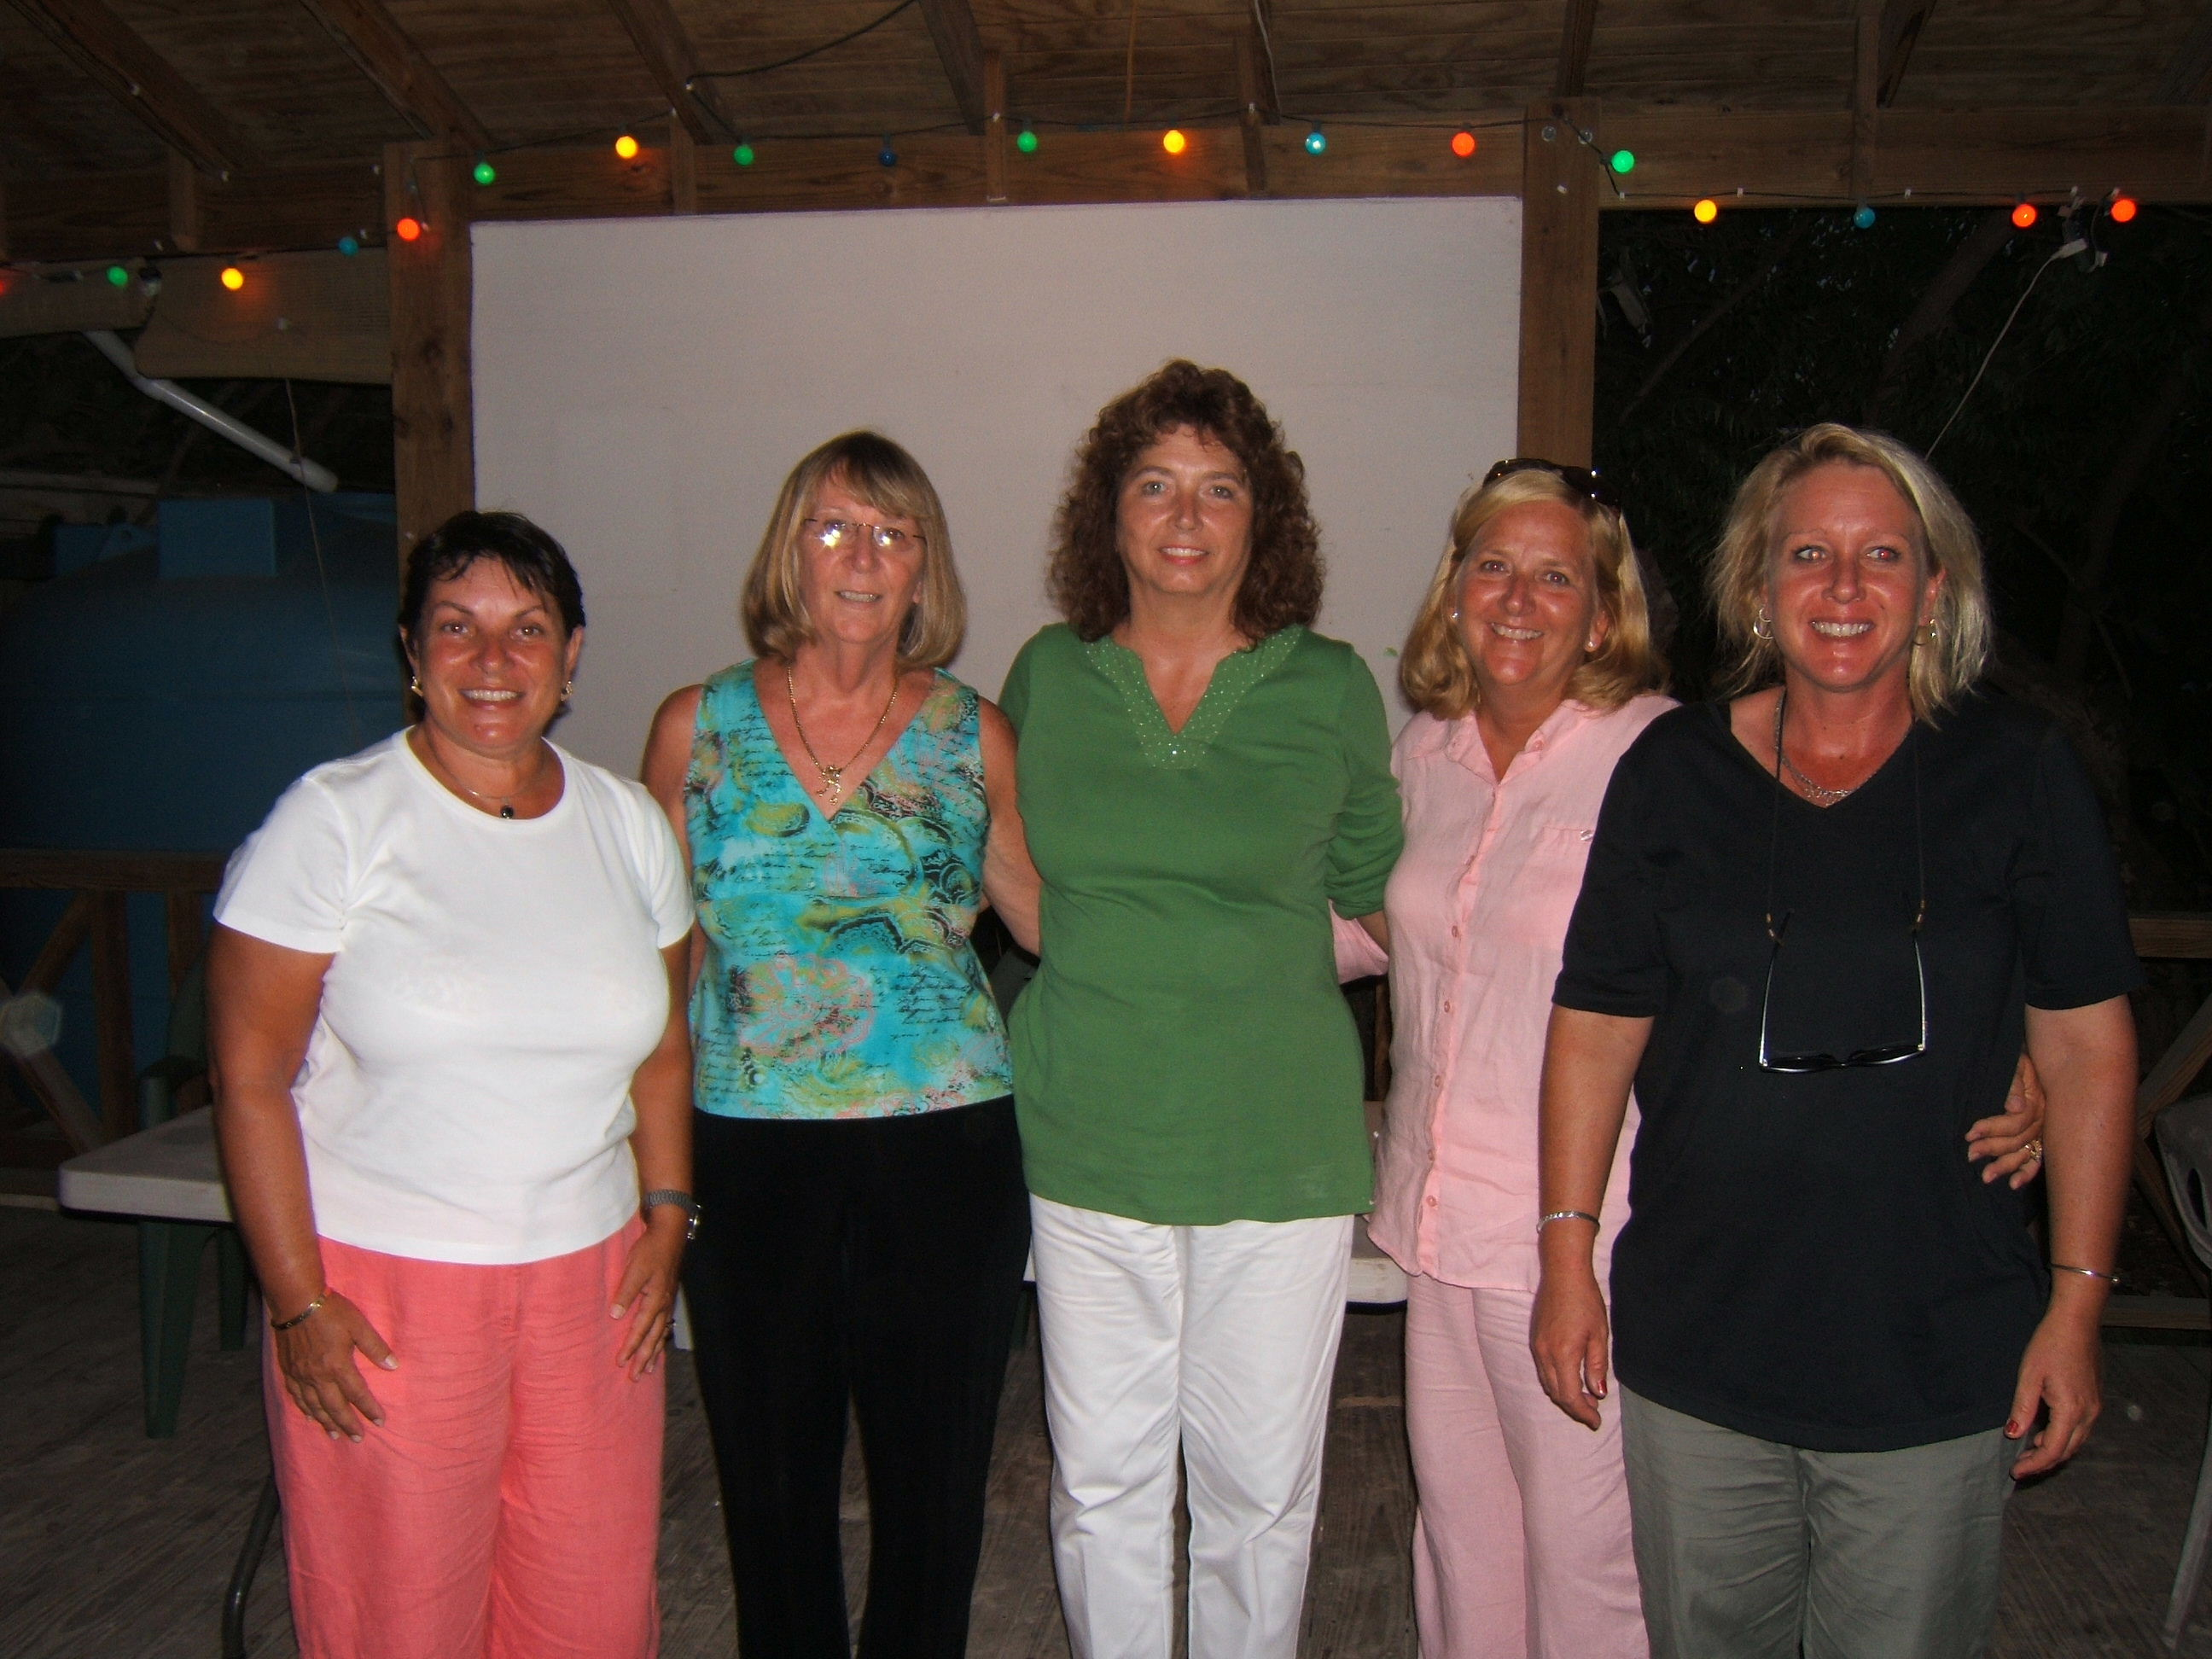

AARF Executive Board – fm left: Gayle Gurvey, Chris Carty, Jackie Pascher, Suzie Donahue & Amy Williams

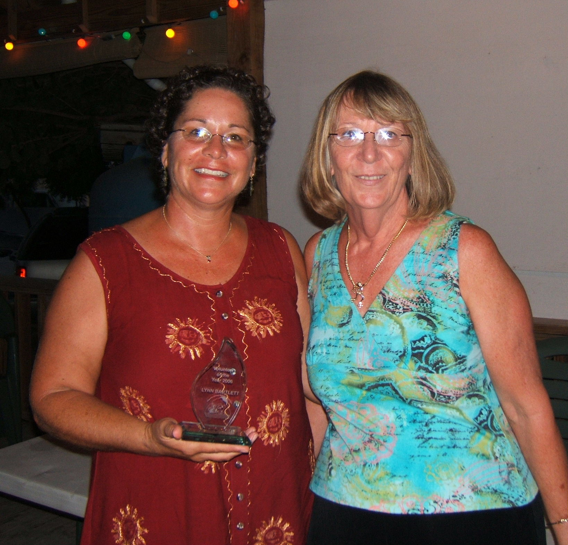

Lynn Bartlett Volunteer of the Year 2006 with AARF President Chris Carty

